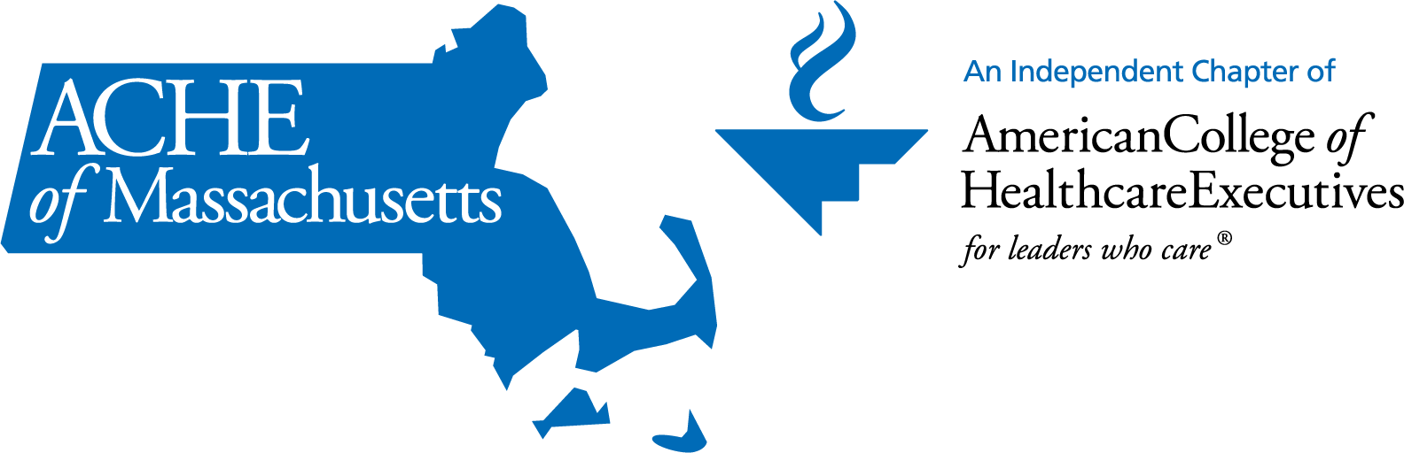
ACHE of Massachusetts Diversity and Inclusion Leader Award
Self-Nomination Form
Overview:
America’s hospitals and health systems are working hard to ensure that every person in every community receives high-quality, equitable and safe care. To do that, we must eliminate health and health care disparities that continue to exist for far too many racially, ethnically and culturally diverse individuals. (This description was copied from the Equity of Care website.)

In 2015, to address these efforts, the American Hospital Association launched its #123forEquity pledge campaign. In a joint effort the American College of Healthcare Executives, American Hospital Association, Association of American Medical Colleges, Catholic Health Association of the United States, and America’s Essential Hospitals stood together in a call to action to eliminate health care disparities by:

- increasing the collection and use of race, ethnicity and language preference data;
- increasing cultural competency training;
- increasing diversity in governance and leadership; and
- improve and strengthen community partnerships

To learn more about the #123forEquity pledge go to: http://www.equityofcare.org/

Award Focus:
As one of the pledged organizations who took the “#123forEquity Pledge”, you made the following commitment: (We welcome nominations from organizations that have not taken the pledge.)
- TAKE THE PLEDGE - Pledge to achieve the three areas of the Call to Action.
Why did your organization take the pledge? If an organization has not taken the #123 pledge, what would you say to encourage them to do so?

- TAKE ACTION – Implement strategies that are reflected in your strategic plan and supported by your board and leadership. Here are some further questions:
  - Increasing the collection of race, ethnicity, sexual orientation, gender identity, ADA, and language preference, etc.: Please describe how your organization utilized the diverse characteristics of the patient to improve access, health outcomes, communication, patient satisfaction, etc.?
  - Increasing cultural responsive training: Please describe the strategy that your organization used to increase cultural responsive training and how it had impacted outcomes of providing culturally responsive patient care? In the journey what were the key learnings and what creative strategies did you used to increase these trainings?
  - Increasing diversity in governance and leadership: At the start of your organization’s journey in increasing diversity in governance and leadership where did you start from and please show how and what increase has been made in those areas? What recruitment strategies were implemented? How were you able to get leadership buy –in in understanding by increasing diversity also increases innovation and organizational outcomes?
  - Improve and strengthen community partnerships: In what ways has your organization improved and strengthen community partnerships? What has resulted in these improved relationships? Please explain and provide examples and or metrics.

- Does your organization measure or increase inclusivity? Please see criteria below:
- Do employees feel they belong at your company?
- Can an employee voice a contrary opinion without fear or negative consequences?
- Are perspectives from your employees included in decision making?

- TELL OTHERS – Achieve the goals and be recognized. Tell your story and share your learnings with others in conference calls and other educational venues including social media to accelerate progress collectively. How have you told others?

Name of person nominating:

Email:

KINDLY RESPOND ON OR BEFORE SEPTEMBER 1, 2020 BY EMAILING info@massache.org
AND ATTACH YOUR NOMINATION FORM TO BE CONSIDERED FOR THE 2nd ANNUAL ACHE OF MA DIVERSITY AND INCLUSION LEADER AWARD, WHICH WILL BE PRESENTED DURING THE VIRTUAL ACHE of MA FALL CONFERENCE ON WEDNESDAY, OCTOBER 21, 2020.

